**Task 1:**

Create a Directory with the Name Linux Practice



**Task2:**

Change to the directory



**Task 3:**

Create a file names TestFile1.txt and add the content to it.



**Task 4:**

Create a Folder named Dummy and try to delete it.



**Task 5:**

Plz check the working directory



**Task 6:**

How do you check all the files and directories in the directory you are in?



**Task 7:**

Create five files named TestFile2.txt.. TestFile3.txt… and so on till TestFile6.txt



**Task 8:**

Copy all files from Dir 1 ti Dir 2



**Task 9:**

Move all files from Dir 2 to Dir 3 (finally ur Dir 2 should be empty)

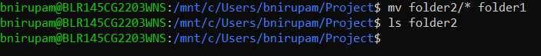

**Task 10:**

Can you plz show me the diff between **rm** and **rmdir** commands with screen shots ?

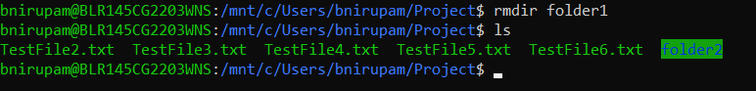



**Task 11:**

Now use specifically use cat command to create a file

And add the dummy text of 2 to 3 paragraphs from the above link Lorem Ipsum.

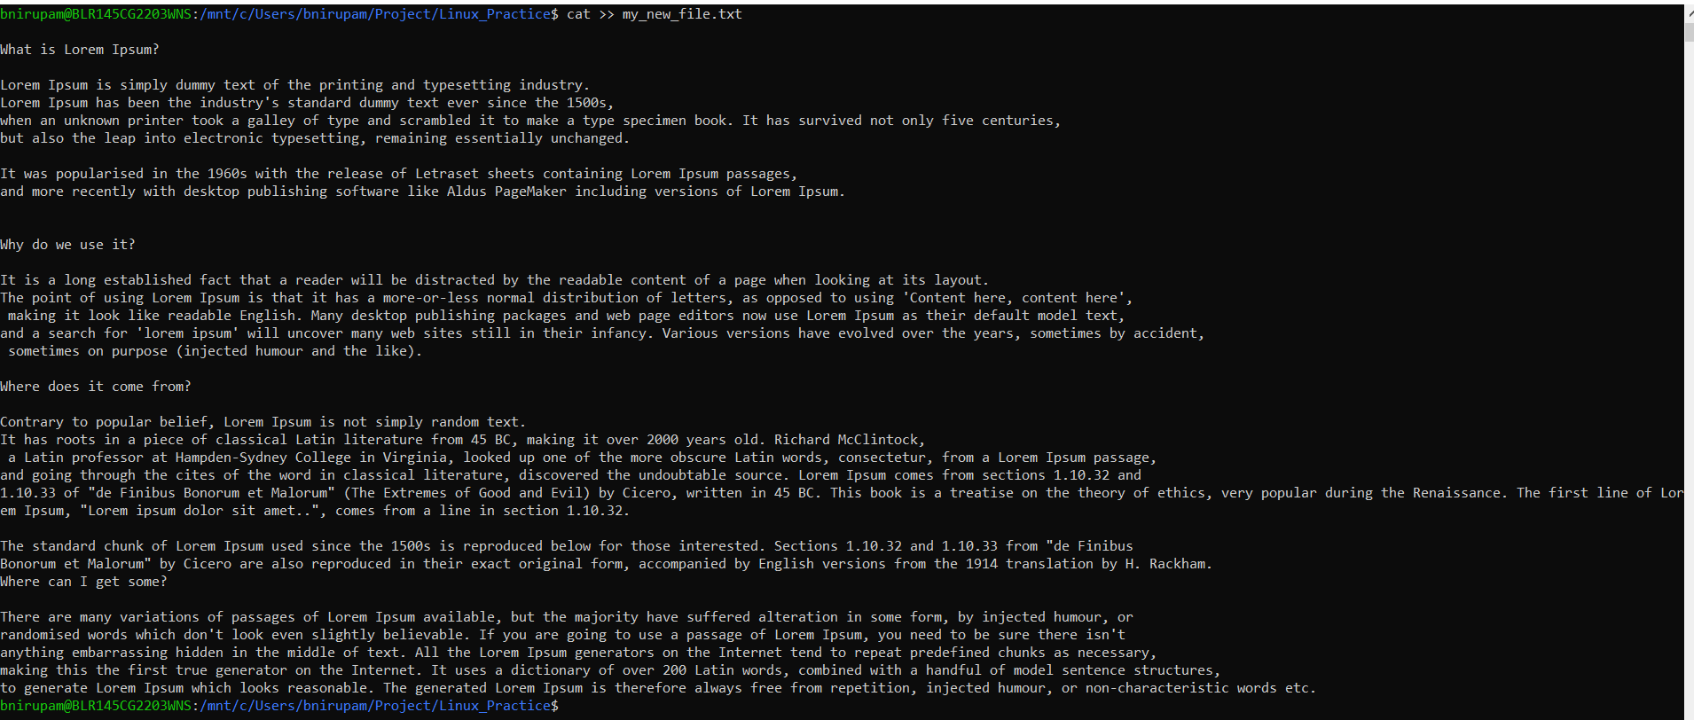

**Task 12:**

How to get only the top part of your file..



**Task 13:**

How to get only the last part of your file



**Task 14:**

Plz add dummy text of 5 to 6 pages in to the same file



And

Now show the file in page by page  
bnirupam@BLR145CG2203WNS:/mnt/c/Users/bnirupam/Project/Linux_Practice$ less my_new_file.txt

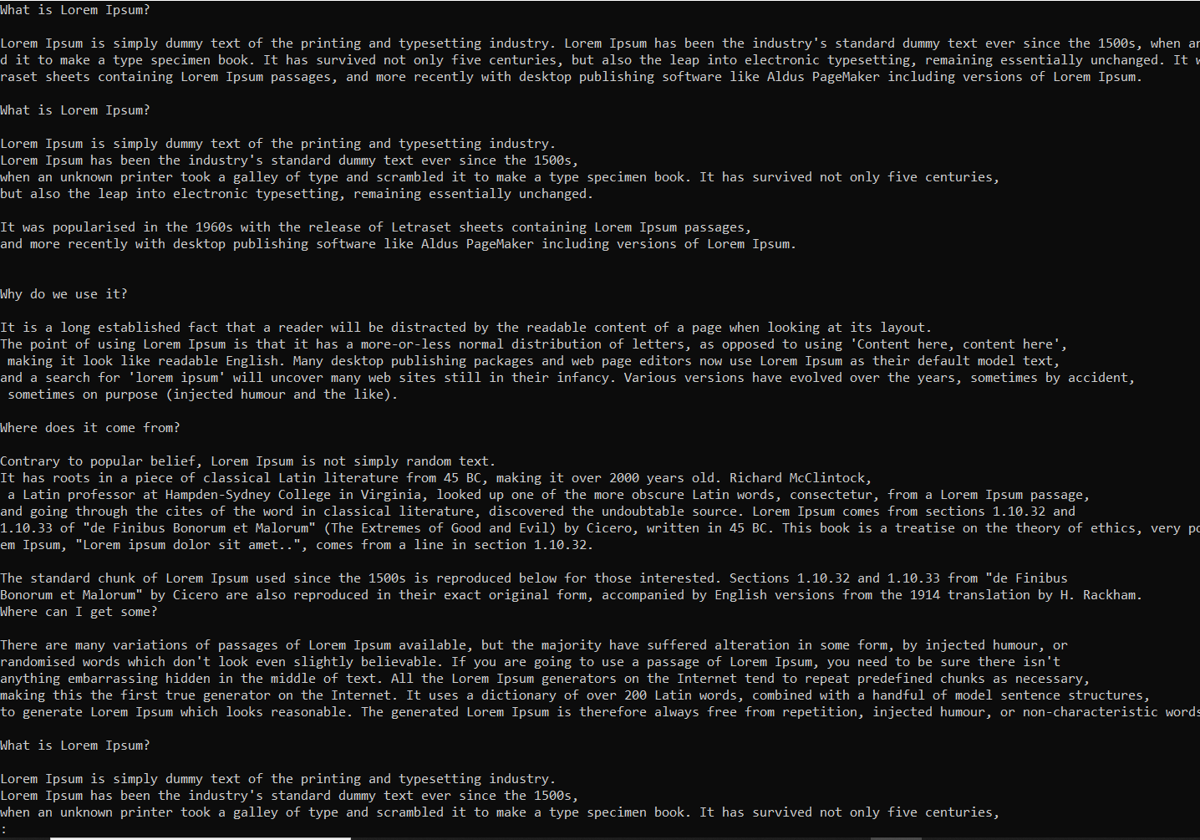

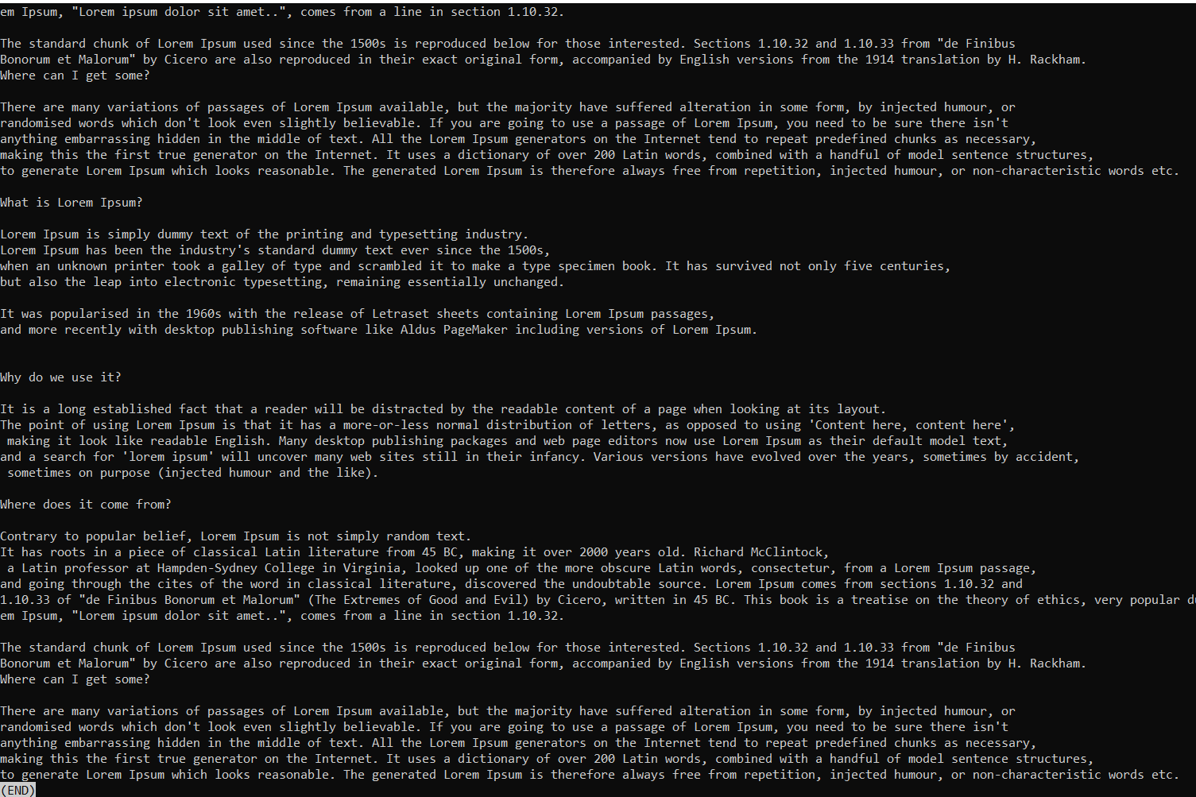

Task 15: Use more command on the above file and find out the diff between less command and more command.

bnirupam@BLR145CG2203WNS:/mnt/c/Users/bnirupam/Project/Linux_Practice$ more my_new_file.txt  
bnirupam@BLR145CG2203WNS:/mnt/c/Users/bnirupam/Project/Linux_Practice$ less my_new_file.txt

**What is e in echo command..?**

The e in the echo command is an option that enables the interpretation of backslash escape sequences. These sequences allow you to insert special characters and formatting into the output.

**Task 16:**

Can you use echo command with -e and see the diff.. Also take a ss and paste .

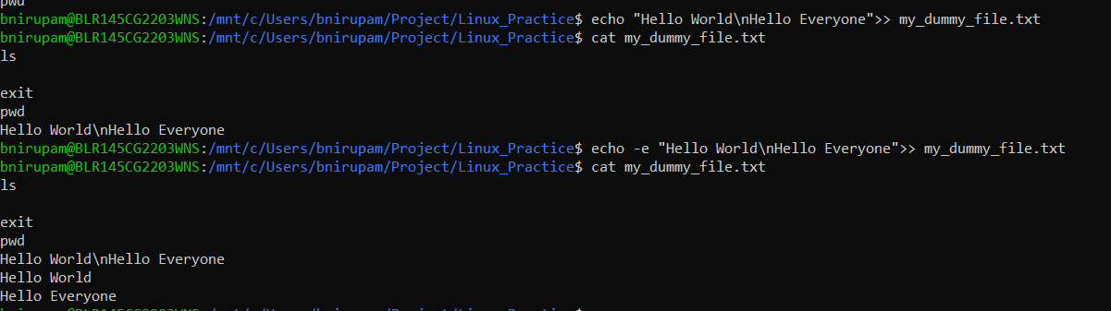

**Task 17:**

What is diff between ls and ls -l command .. ss plz

* ls: Lists file and directory names in a simple, compact format.
* ls -l: Lists file and directory names in a long, detailed format, showing permissions, owner, size, date, and time.

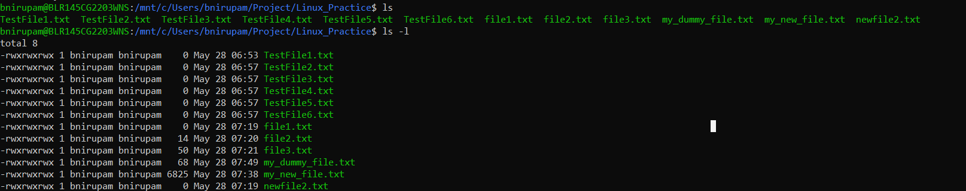

**Task 18:**

Create  a file using **touch** command , **cat** command and **echo** command and take ss (screen shot)..



Also write the difference between touch , cat and echo commands.

* touch: Creates empty files or updates file timestamps
* cat: Displays file content, or can be used interactively to write multi-line content to a file.
* echo: Prints text to the screen, often redirected to write a single line of text to a file.

**Task 19:**

Can you guys try to display the calendar by using a command..

Hint: use cal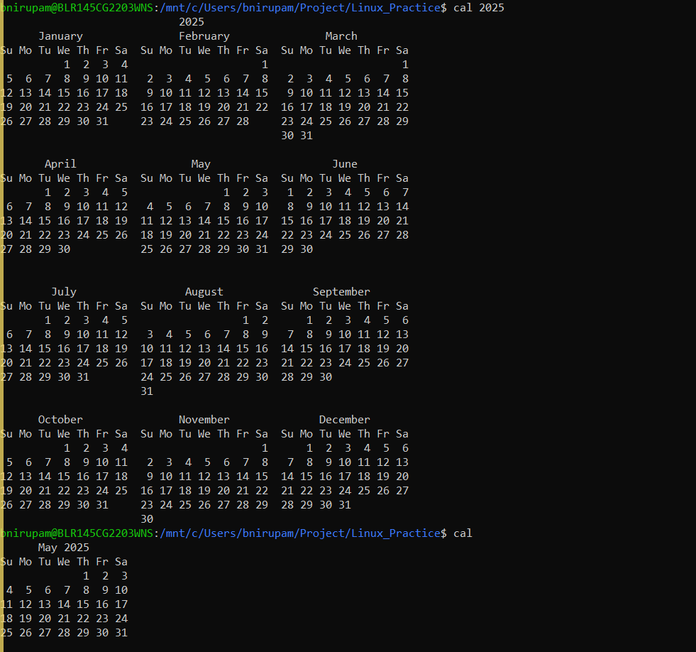

**Task 20:**

Can you go back to 1 directory .. at a time whats the command



**Task 21:**

How to know whose user u are working on ?

Hint: use whoami command



**Task 22:**

Try to find out who is peeping into your system..

Use users, who and w commands with ss

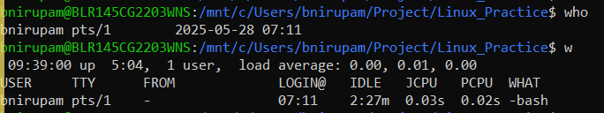

Task 23:

Can you guys try to check how much disk space is consumed..

Hint : use df

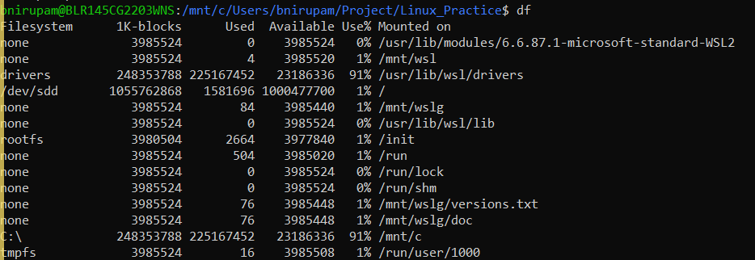

Task 24:

Can you plz try using the below commands

|  |  |
| --- | --- |
| **Prefix** | **Description** |
| **-** | **Regular file**, such as an ASCII text file, binary executable, or hard link. |
| **b** | **Block special file**. Block input/output device file such as a physical hard drive. |
| **c** | **Character special file**. Raw input/output device file such as a physical hard drive. |
| **d** | **Directory** which contains a listing of other files and directories. |
| **l** | **Symbolic link file**. Links on any regular file. |
| **p** | **Named pipe**. A mechanism for interprocess communications. |
| **s** | **Socket** which is used for interprocess communication. |

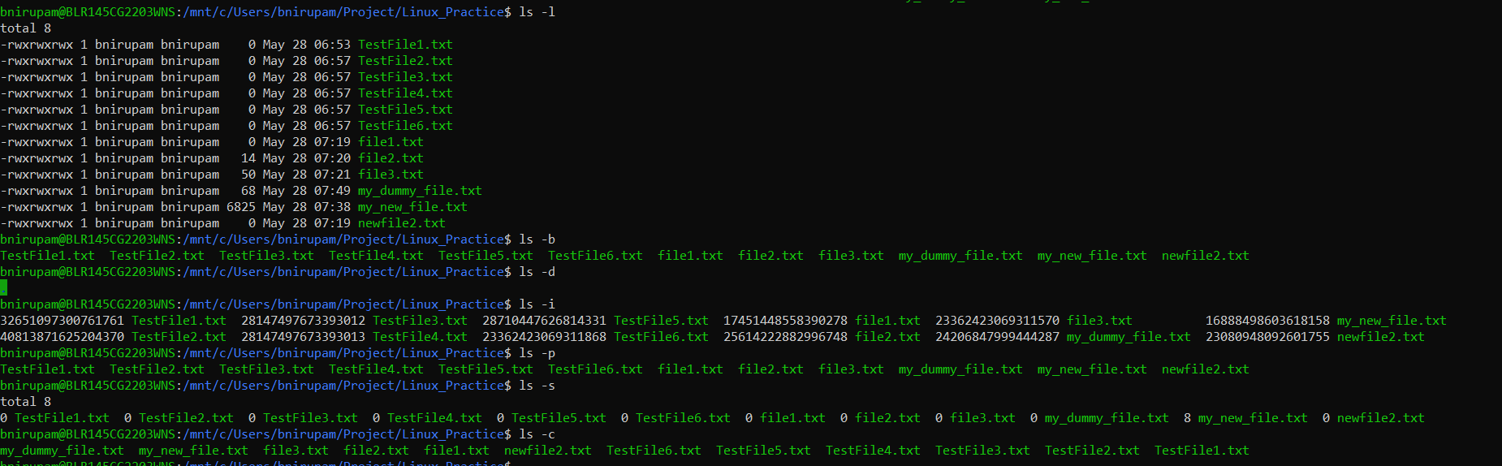

**Task 25:** Find the list pf all files ending with .txt

Hint : use * in ls



**Task 26:**

In Linux all the hidden files starts with . (period)

How to check all the hidden files in Linux..

Hint : use  ls -a



**Task 27:**

What is the difference between . and .. in linux

Line 1 line for each

* . (Single dot): Represents the current directory.
* .. (Double dot): Represents the parent directory (the directory immediately above the current one).

i.e.

**Task 28:**

Can you create a file using vi editor and show the details in ss

Hint:

 Esc is for come out of the edit mode

Press two keys Shift &plus; ZZ together to come out of the file completely

* I - to insert

To move inside the file

* **l** key to move to the right side.
* **h** key to move to the left side.
* **k** key to move upside in the file.
* **j** key to move downside in the file.  
    
  bnirupam@BLR145CG2203WNS:/mnt/c/Users/bnirupam/Project/Linux_Practice$ vi my_vi_testfile.txt  
    
  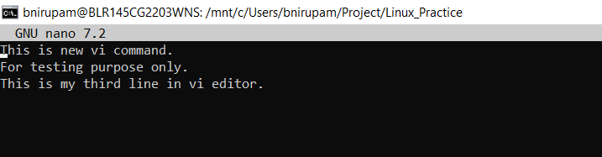

**Task 29:**

How to find the no of words in the file

Hint: use wc

Here is the detail of all the four columns of wc command  −

* **First Column** − Represents the total number of lines in the file.
* **Second Column** − Represents the total number of words in the file.
* **Third Column** − Represents the total number of bytes in the file. This is the actual size of the file.
* **Fourth Column** − Represents the file name.



**Task 30:**

What is the use of cat -b myfilename.txt command?

It is used to display the contents of myfilename.txt with line numbers, but only for non-empty lines.



**Task 31:**

Can I use the wc with 2 or more files?

Wc file1 file2 file3

When we provide multiple files to **wc**, it will show you the word, line, and/or character counts for each individual file, and then it will also provide a total count for all the files combined.



Task 32:

How to copy content of one file to another file

Hinf use cp:

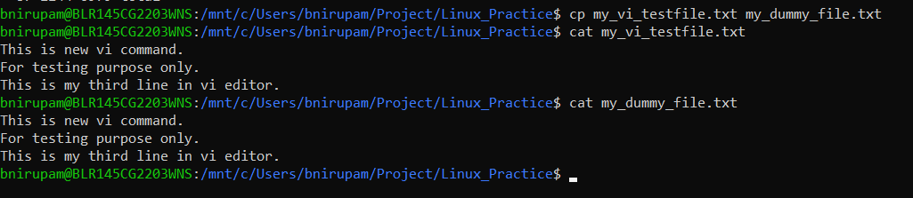

**Task 33:**

Now I want to rename my file with MYFILENEW can i do that if so how ?

Hint use : mv



**Task 34:**

Can i remove or delete multiple files in linux..? How?

  
**Task 35:**

In directory / slash is root  …  can you try cd / what is it doing?

  
It is used to change your current working directory to the root directory of the file system.

Linux directory structure: plz have a reading and try to remember..

|  |  |
| --- | --- |
| **Directory** | **Description** |
| **/bin** | important binary applications |
| **/boot** | boot configuration files, kernels, and other files needed at boot time. |
| **/dev** | System device files. |
| **/etc** | configuration files, startup scripts, etc. |
| **/home** | List of home directories for different users |
| **/lib** | system libraries, shared libraries |
| **/lost+found** | a lost+found system for files that exist under the root (/) directory |
| **/media** | automatically mounted (loaded) partitions on your hard drive and removable media such as CDs, digital cameras, etc. |
| **/mnt** | manually mounted filesystems on your hard drive |
| **/opt** | 3rd part applications to be installed |
| **/proc** | Maintains information about the state of the system, including currently running processes. |
| **/root** | root user's home directory. |
| **/sbin** | important system binaries |
| **/srv** | contain files that are served to other systems |
| **/sys** | system files |
| **/tmp** | temporary files |
| **/usr** | applications and files that are mostly available for all users to access |
| **/var** | variable files such as logs and databases |

**Task 36:**

What is the way to go to home directory ?

Hint : use cd ~

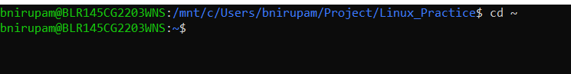

**Task 37:**

If i want to move to different users home directory

Hint : use ~username





**Task 38:**

Chmods:

